Please have a look at my current configuration and the installation history at the end of this document.

Start Protocol

2012-10-19 11:00h

Behaviour: Titanium Studio was hanging in an indexing loop

User Action: Force Titanium Studio to quit via Force Stopp (Apple menu)

User Action: Restart iMac

User Action: Delete all index files and log files in the workspace

11:10h

User Action: Start Titanium Studio (it’s a new Workspace, including one bigger project)

Behaviour: Titanium Studio starts up, rebuilding indices

11:20h ready

The index file size is 73,7 MB !

Showing error in .log, line 31:
[ERROR] Failed to log into Node.ACS: Node.ACS is not configured properly. The "acs" executable/node package is not installed.

Showing error in .log, line 34:
[ERROR] Trying to write a string that is too long and will overflow the recorded length maximum. index file: /Users/kmueller/Documents/Titanium Studio 3 Mazda/.metadata/.plugins/com.aptana.index.core/2274320065.index.tmp, length: 223.908, string: 'Resources/database/sampleData_db_list_12

The mentioned string is located in a json file (sampleData_db_list_12.js) which is located under the Resources folder. It has a size of 487 kB.

11:31h
User Action: Try to update Titanium SDK

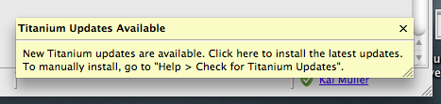
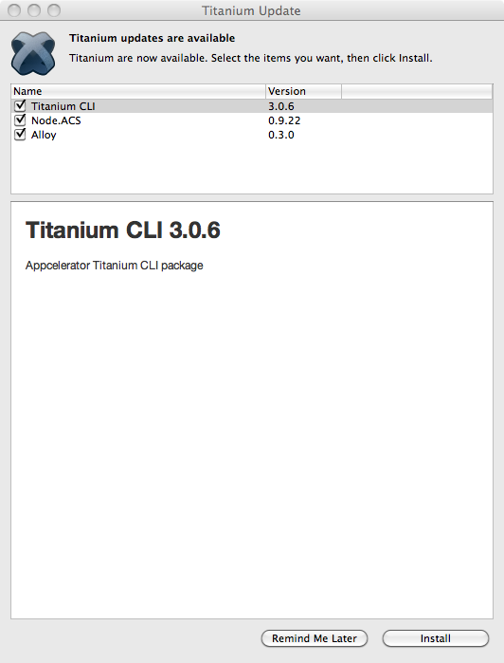

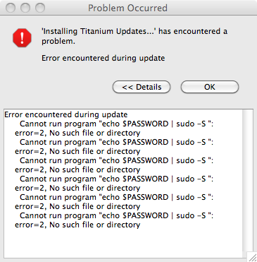

!ENTRY com.appcelerator.titanium.update 4 4 2012-10-19 11:33:28.176
!MESSAGE Error encountered during update
!SUBENTRY 1 com.appcelerator.titanium.nodejs.core 4 0 2012-10-19 11:33:28.177
!MESSAGE Cannot run program "echo $PASSWORD | sudo -S ": error=2, No such file or directory
!STACK 0
java.io.IOException: Cannot run program "echo $PASSWORD | sudo -S ": error=2, No such file or directory
at java.lang.ProcessBuilder.start(ProcessBuilder.java:460)
at com.aptana.core.util.ProcessUtil.startProcess(ProcessUtil.java:327)
at com.aptana.core.util.ProcessUtil.doRun(ProcessUtil.java:322)
at com.aptana.core.util.ProcessUtil.run(ProcessUtil.java:273)
at com.aptana.core.util.ProcessUtil.run(ProcessUtil.java:235)
at com.appcelerator.titanium.nodejs.internal.core.NodePackageManager.install(NodePackageManager.java:144)
at com.appcelerator.titanium.update.TitaniumNPMRelease.install(TitaniumNPMRelease.java:37)
at com.appcelerator.titanium.update.TitaniumSDKUpdater.installTitaniumUpdates(TitaniumSDKUpdater.java:560)
at com.appcelerator.titanium.update.TitaniumSDKUpdater.access$1(TitaniumSDKUpdater.java:509)
at com.appcelerator.titanium.update.TitaniumSDKUpdater$2.run(TitaniumSDKUpdater.java:344)
at org.eclipse.core.internal.jobs.Worker.run(Worker.java:54)
Caused by: java.io.IOException: error=2, No such file or directory
at java.lang.UNIXProcess.forkAndExec(Native Method)
at java.lang.UNIXProcess.<init>(UNIXProcess.java:53)
at java.lang.ProcessImpl.start(ProcessImpl.java:91)
at java.lang.ProcessBuilder.start(ProcessBuilder.java:453)
... 10 more

Host OS: Mac OS X
OS Arch: x86
JRE Version: 1.6.0_35
JRE Vendor: Apple Inc.
JRE Home: /System/Library/Java/JavaVirtualMachines/1.6.0.jdk/Contents/Home
Install Directory: file:/Applications/Titanium Studio/
Version:
VM Arguments: -Xms40m
-Xmx1024m
-Declipse.p2.unsignedPolicy=allow
-Declipse.log.size.max=10000
-Declipse.log.backup.max=5
-Xdock:icon=../Resources/titanium.icns
-XstartOnFirstThread
-Dorg.eclipse.swt.internal.carbon.smallFonts
-XX:MaxPermSize=256m
-Djava.class.path=/Applications/Titanium Studio/plugins/org.eclipse.equinox.launcher_1.2.0.v20110502.jar

Workspace Directory: file:/Users/kmueller/Documents/Titanium Studio 3 Mazda/
Language: de_DE

Titanium SDK Version: 1.6.2
Mobile SDK Timestamp: 04/18/11 17:16
Mobile SDK Build Number: 878906d
Titanium SDK Location: /Library/Application Support/Titanium/mobilesdk/osx/1.6.2

Titanium SDK Version: 1.7.0
Mobile SDK Timestamp: 03/31/11 12:08
Mobile SDK Build Number: f6cae16
Titanium SDK Location: /Library/Application Support/Titanium/mobilesdk/osx/1.7.0

Titanium SDK Version: 1.7.1
Mobile SDK Timestamp: 06/21/11 14:28
Mobile SDK Build Number: 1293a6d
Titanium SDK Location: /Library/Application Support/Titanium/mobilesdk/osx/1.7.1

Titanium SDK Version: 1.7.2
Mobile SDK Timestamp: 07/21/11 09:36
Mobile SDK Build Number: 97c3689
Titanium SDK Location: /Library/Application Support/Titanium/mobilesdk/osx/1.7.2

Titanium SDK Version: 1.7.3
Mobile SDK Timestamp: 10/17/11 13:44
Mobile SDK Build Number: dcf4257
Titanium SDK Location: /Library/Application Support/Titanium/mobilesdk/osx/1.7.3

Titanium SDK Version: 1.7.4
Mobile SDK Timestamp: 10/31/11 10:30
Mobile SDK Build Number: 9b47b22
Titanium SDK Location: /Library/Application Support/Titanium/mobilesdk/osx/1.7.4

Titanium SDK Version: 1.7.5
Mobile SDK Timestamp: 11/02/11 17:00
Mobile SDK Build Number: ab20af7
Titanium SDK Location: /Library/Application Support/Titanium/mobilesdk/osx/1.7.5

Titanium SDK Version: 1.8.0.1
Mobile SDK Modules API Version:2
Mobile SDK Timestamp: 12/22/11 13:09
Mobile SDK Build Number: fbdc96f
Titanium SDK Location: /Library/Application Support/Titanium/mobilesdk/osx/1.8.0.1

Titanium SDK Version: 1.8.0.1
Mobile SDK Modules API Version:2
Mobile SDK Timestamp: 12/17/11 19:53
Mobile SDK Build Number: c903964
Titanium SDK Location: /Library/Application Support/Titanium/mobilesdk/osx/1.8.0.1.RC3

Titanium SDK Version: 1.8.0.1
Mobile SDK Timestamp: 12/08/11 12:47
Mobile SDK Build Number: 99d7091...
Titanium SDK Location: /Library/Application Support/Titanium/mobilesdk/osx/1.8.0.1.v20111208124750

Titanium SDK Version: 1.8.1
Mobile SDK Modules API Version:2
Mobile SDK Timestamp: 01/27/12 17:31
Mobile SDK Build Number: a24502a
Titanium SDK Location: /Library/Application Support/Titanium/mobilesdk/osx/1.8.1

Titanium SDK Version: 1.8.2
Mobile SDK Modules API Version:2
Mobile SDK Timestamp: 02/23/12 17:46
Mobile SDK Build Number: 59b3a90
Titanium SDK Location: /Library/Application Support/Titanium/mobilesdk/osx/1.8.2

Titanium SDK Version: 2.0.0
Mobile SDK Modules API Version:2
Mobile SDK Timestamp: 03/21/12 23:17
Mobile SDK Build Number: 1527faa
Titanium SDK Location: /Library/Application Support/Titanium/mobilesdk/osx/2.0.0.v20120321231752

Titanium SDK Version: 2.0.1
Mobile SDK Modules API Version:2
Mobile SDK Timestamp: 04/12/12 16:33
Mobile SDK Build Number: 999c68a
Titanium SDK Location: /Library/Application Support/Titanium/mobilesdk/osx/2.0.1.GA

Titanium SDK Version: 2.0.1
Mobile SDK Modules API Version:2
Mobile SDK Timestamp: 04/12/12 16:33
Mobile SDK Build Number: 999c68a
Titanium SDK Location: /Library/Application Support/Titanium/mobilesdk/osx/2.0.1.GA2

Titanium SDK Version: 2.0.2
Mobile SDK Modules API Version:2
Mobile SDK Timestamp: 05/30/12 10:21
Mobile SDK Build Number: 2ff31a3
Titanium SDK Location: /Library/Application Support/Titanium/mobilesdk/osx/2.0.2.GA

Titanium SDK Version: 2.1.0
Mobile SDK Modules API Version:2
Mobile SDK Timestamp: 06/28/12 12:16
Mobile SDK Build Number: 6e3cab6
Titanium SDK Location: /Library/Application Support/Titanium/mobilesdk/osx/2.1.0.GA

Titanium SDK Version: 2.1.1
Mobile SDK Modules API Version:2
Mobile SDK Timestamp: 07/27/12 14:01
Mobile SDK Build Number: 0fd84a2
Titanium SDK Location: /Library/Application Support/Titanium/mobilesdk/osx/2.1.1.GA

Titanium SDK Version: 2.1.2
Mobile SDK Modules API Version:2
Mobile SDK Timestamp: 08/24/12 14:46
Mobile SDK Build Number: ed7f777
Titanium SDK Location: /Library/Application Support/Titanium/mobilesdk/osx/2.1.2.GA

Titanium CLI Version: unknown

Alloy Version: 0.2.42

Node.ACS Version: unknown

Installation History
2012-09-26 Titanium Studio 2.1.3.201209250912-25092012091604 OK !!!
2012-10-13 Titanium Studio 3.0.1.201210122152-12102012215516 Nightmare
2012-10-15 Titanium Studio 3.0.1.201210141904-14102012190818 Nightmare
2012-10-16 Titanium Studio 3.0.1.201210151954-15102012195515 Nightmare
Any further update is not possible.
Since Version 3.0.1 the product is named „%product.name“ instead of „Titanium Studio“:

